Keys in sql

Superkey:

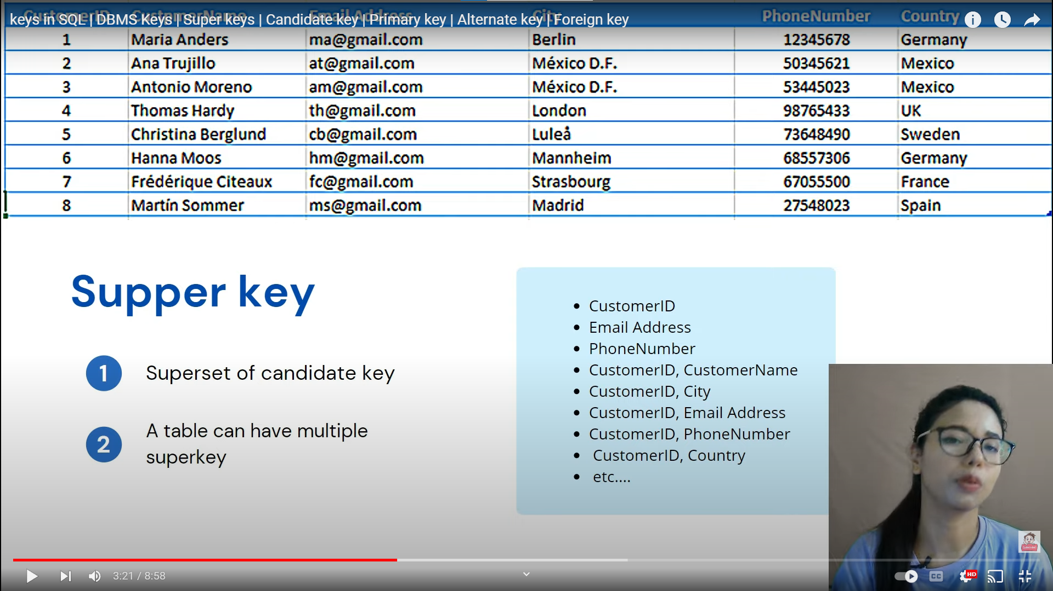

Candidate key

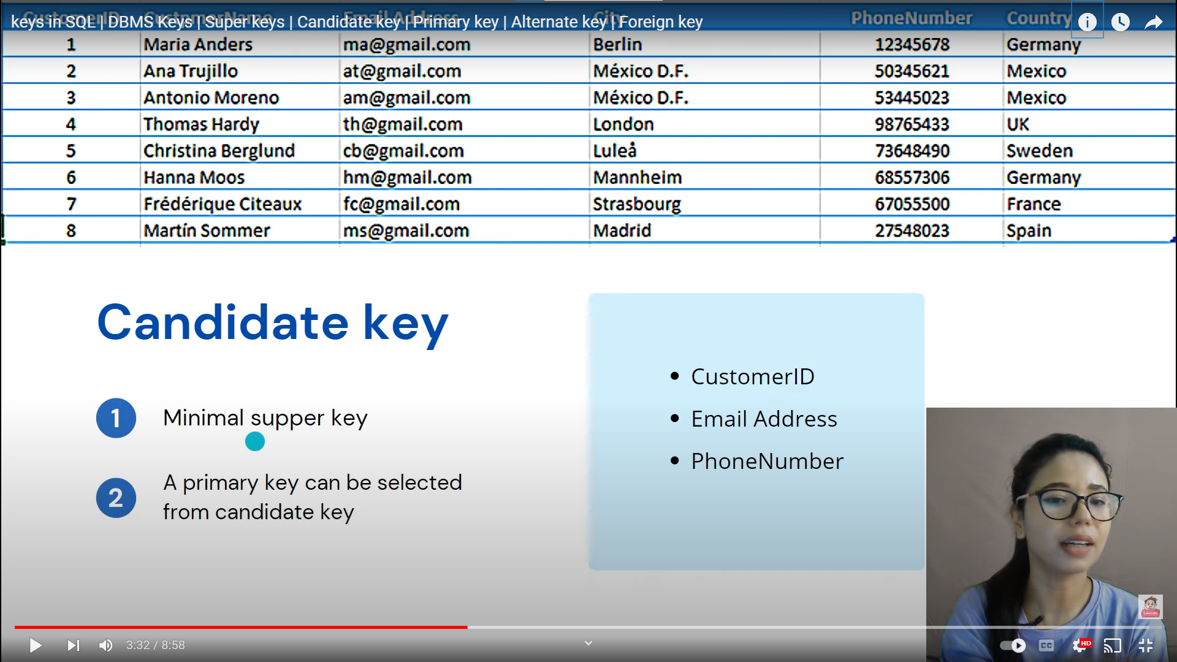

Primary key

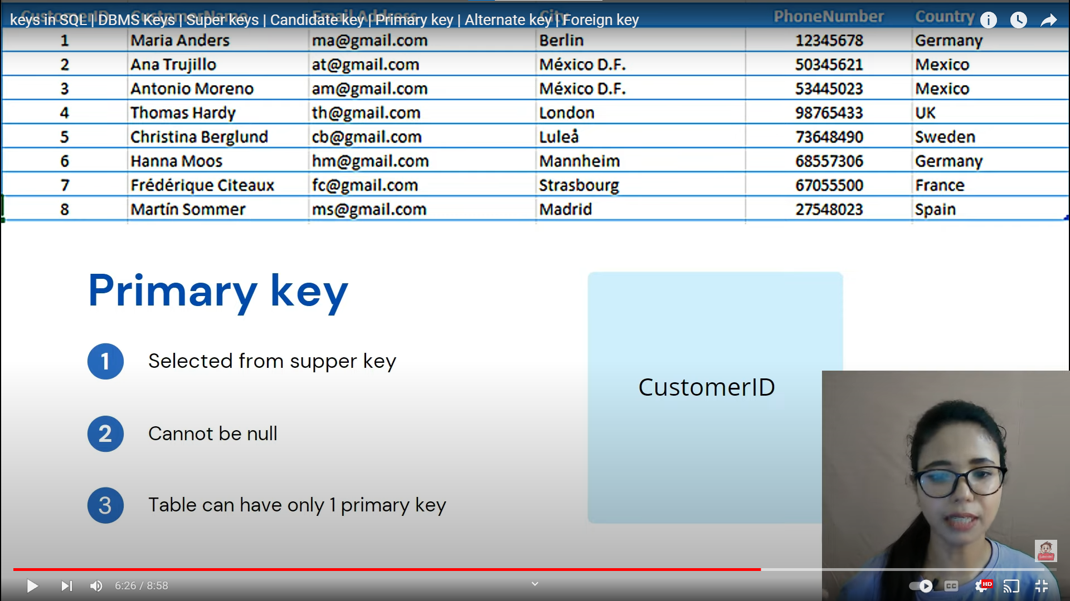

ALTERNATE KEY

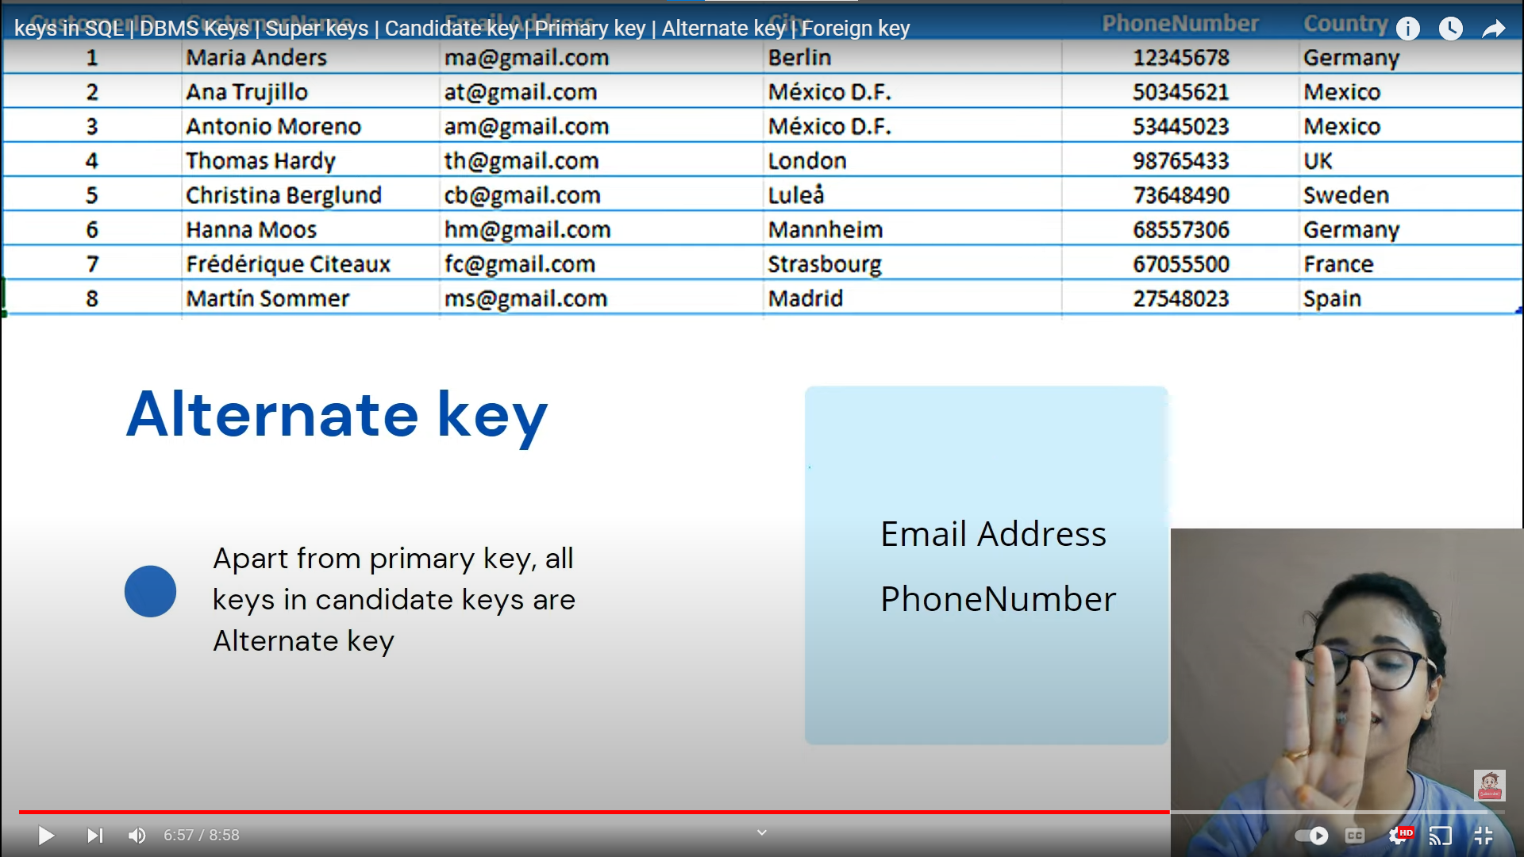

Foreignkey

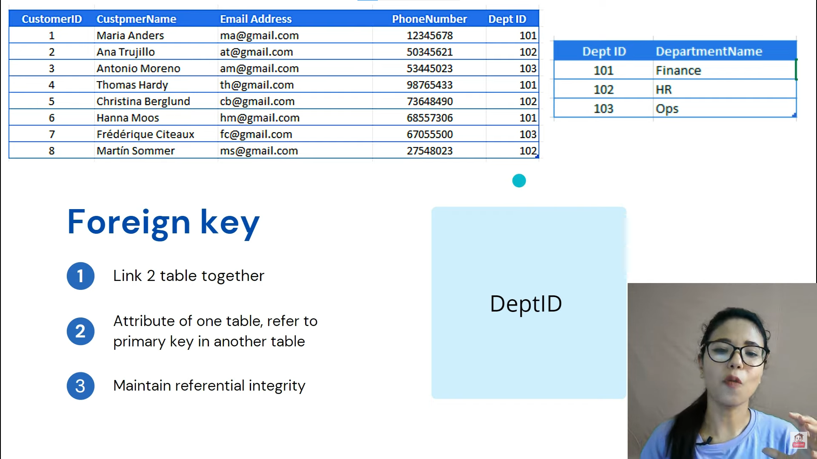

What are constraints

Constraints are the rules that we can apply on the type of data in a table. That is, we can specify the limit on the type of data that can be stored in a particular column in a table using constraints.

The available constraints in SQL are:

* **NOT NULL**: This constraint tells that we cannot store a null value in a column. That is, if a column is specified as NOT NULL then we will not be able to store null in this particular column any more.
* **UNIQUE**: This constraint when specified with a column, tells that all the values in the column must be unique. That is, the values in any row of a column must not be repeated.
* **PRIMARY KEY**: A primary key is a field which can uniquely identify each row in a table. And this constraint is used to specify a field in a table as primary key.
* **FOREIGN KEY**: A Foreign key is a field which can uniquely identify each row in a another table. And this constraint is used to specify a field as Foreign key.
* **CHECK**: This constraint helps to validate the values of a column to meet a particular condition. That is, it helps to ensure that the value stored in a column meets a specific condition.
* **DEFAULT**: This constraint specifies a default value for the column when no value is specified by the user.

**ANY**

ANY compares a value to each value in a list or results from a query and evaluates to true if the result of an inner query contains at least one row.

* ANY return true if any of the subqueries values meet the condition.
* ANY must be preceded by comparison operators. **Syntax:**

SELECT column_name(s)

FROM table_name

WHERE column_name comparison_operator ANY

(SELECT column_name

FROM table_name

WHERE condition(s));

**Queries**

* Find the Distinct CategoryID of the products which have any record in OrderDetails Table.

SELECT DISTINCT CategoryID

FROM Products

WHERE ProductID = ANY (SELECT ProductID

FROM OrderDetails);

* Output: 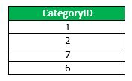
* Finds any records in the OrderDetails table that Quantity = 9.

SELECT ProductName

FROM Products

WHERE ProductID = ANY (SELECT ProductID

FROM OrderDetails

WHERE Quantity = 9);

* 